ST. ERVAN PARISH COUNCIL
Jacqui Peskett
Parish Clerk

Email: stervanpc@outlook.com
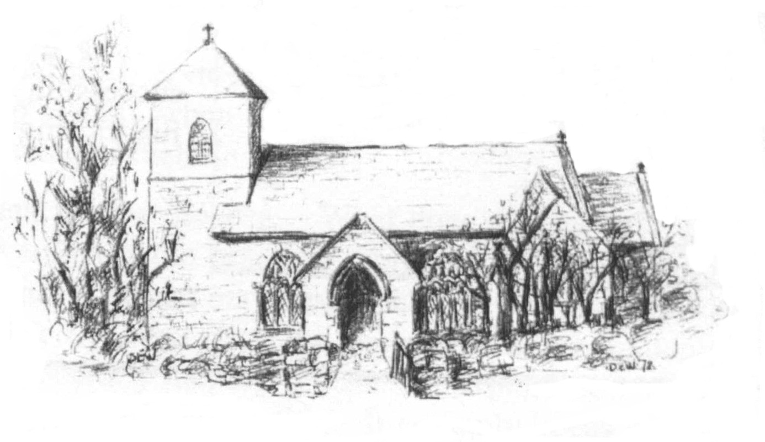

23rd February 2024

I hereby give notice that the ANNUAL MEETING of ST ERVAN PARISH COUNCIL will be held at St Ervan Village Hall on Tuesday 5th March @ 7pm

All members of the Council are herby requested to attend for the purposes of considering and resolving upon the business about to be transacted at the meeting as set out in the agenda.

Jacqui Peskett
Clerk/RFO to St Ervan Parish Council

- INTRODUCTION / WELCOME

2. APOLOGIES

3.MINUTES of the meeting of 2023 Annual Meeting.

4. MATTERS ARISING, if any.

5. PARISH COUNCIL ANNUAL REPORT.

6. ANNUAL CORNWALL COUNCILLOR REPORT.

9. QUESTIONS FROM THE FLOOR.

10. ITEMS TO TAKE TO THE PARISH COUNCIL for consideration.

